EXP 22 - SIMULATION AND ANALYSIS OF BPSK MODULATION USING CONSTELLATION DIAGRAMS IN MATLAB

CODE:

clc;
clear;
close all;
% Generate Random Bits
N = 100;
bits = randi([0 1],N,1);
% BPSK Modulation
bpsk = 2*bits - 1; % 0 -> -1, 1 -> +1
% Add AWGN Noise
rx = awgn(bpsk,10,'measured');
% Constellation Diagram
figure;
subplot(2,1,1)
stem(bits)
title('Input Binary Data')
grid on
subplot(2,1,2)
scatter(real(rx), imag(rx),'filled')
title('BPSK Constellation Diagram')
xlabel('In-Phase')
ylabel('Quadrature')
grid on
axis([-2 2 -2 2])

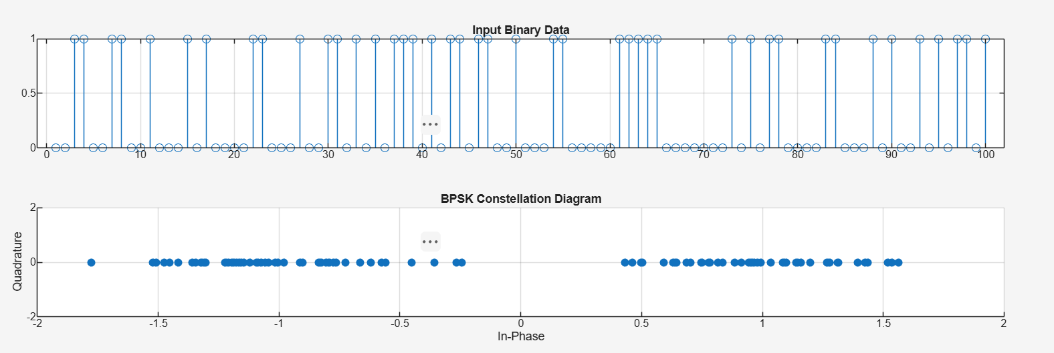
OUTPUT:

